create table customers (customer_id int primary key, first_name varchar(20), last_name varchar(30));

insert into customers values(101,'Avi','Roy');

insert into customers values(102,'Avik','Pal');

insert into customers values(103,'Avinay','Das');

insert into customers values(104,'Avijit','Roy');

create table new_order (order_id int primary key, total_amount int,customer_id int references customers(customer_id));

insert into new_order values (111,12000,101);

insert into new_order values (222,12000,103);

insert into new_order values (333,12000,102);

insert into new_order values (444,12000,101);

select customers.first_name,customers.last_name,new_order.total_amount

from customers

inner join new_order on customers.customer_id=new_order.customer_id;

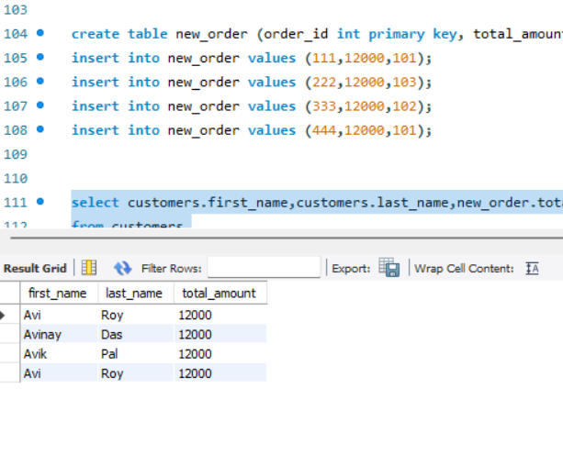

create table department (department_id int primary key, department_name varchar(30));

insert into department values (191,'VLSI');

insert into department values (181,'DSP');

insert into department values (171,'MPMC');

insert into department values (161,'DIVP');

insert into department values (151,'MATH');

create table employees (employee_id int primary key, first_name varchar(20), last_name varchar(30), department_id int references department(department_id));

insert into employees values (1001, 'Daniel','Plainview', 191);

insert into employees values (1002, 'HW','Plainview', 181);

insert into employees values (1003, 'Eli','Sunday', 181);

insert into employees values (1004, 'Calvin','Candie', 191);

insert into employees values (1005, 'Colm','Larry', 161);

insert into employees values (1006, 'Benzamin','Button', 171);

select department.department_name, employees.first_name,employees.last_name

from department

left join employees on department.department_id = employees.department_id;

